**My SQL**

**Data Set**

* account.csv
* card.csv
* client.csv
* disp.csv
* district.csv
* loan.csv
* order.csv

**Open the data file in Excel**

**Data - > From Text -> File Name -> Next**

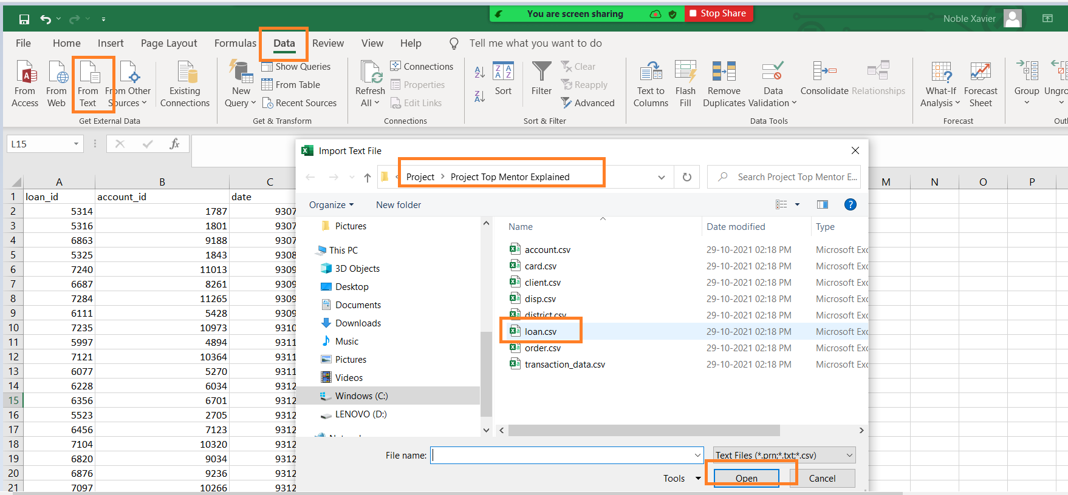

**Create a new Database to load all .csv files**

DROP DATABASE IF EXISTS CAPSTONE_PRJ;

CREATE DATABASE CAPSTONE_PRJ;

USE CAPSTONE_PRJ;

**Load all the Files to MySQL Server database and create separate tables for each file**

Right Click Tables -> Table Data Import Wizard

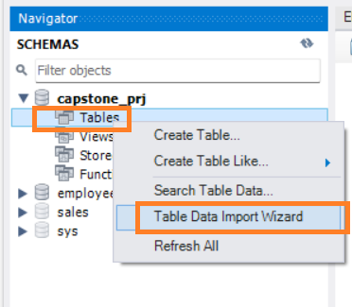

Click **Browse**

Select the folder where data is available

Select **.csv** file Name

**Click Open**

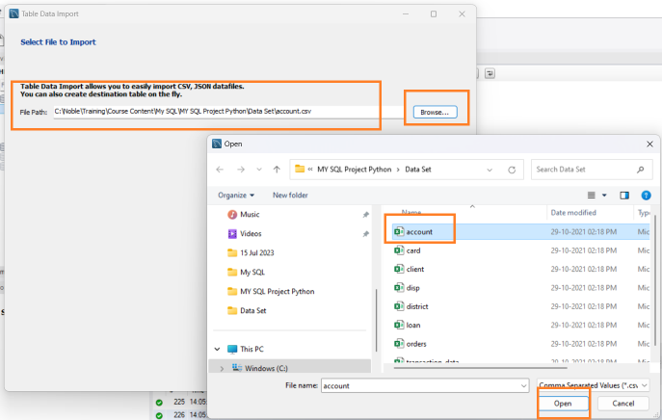

Click Next on Select File to Import

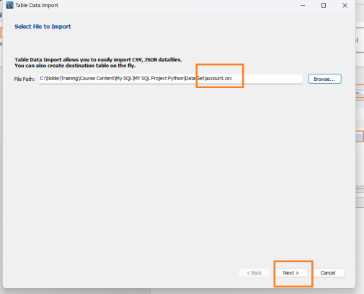

Data Base name and Table Name Auto populate – Update any change required

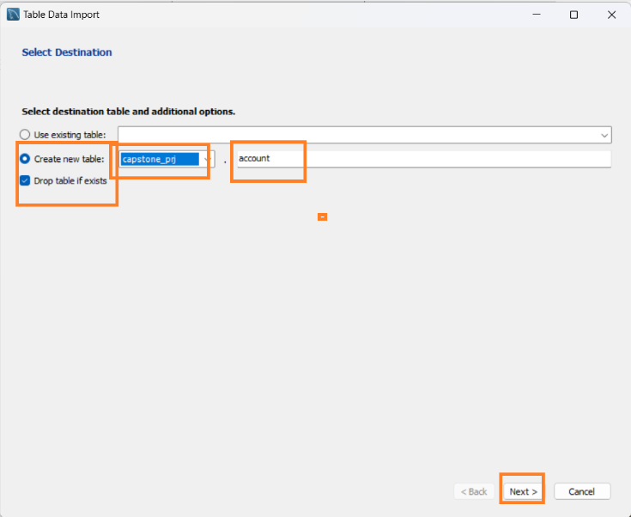

Use Default and click **Next**

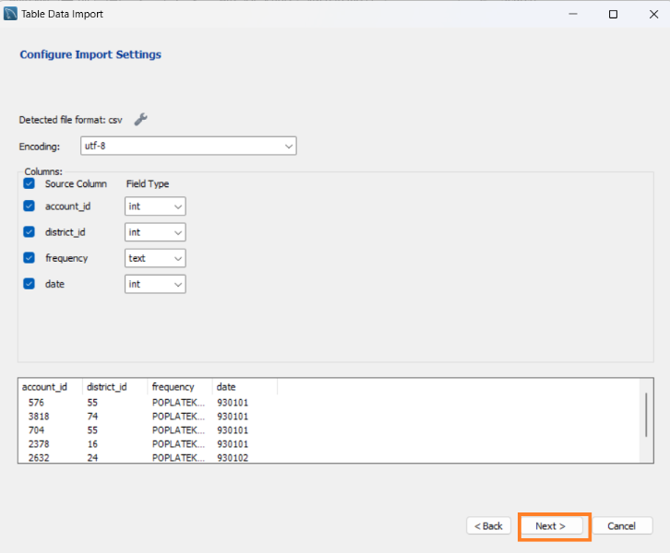

Use Default and click **Next**

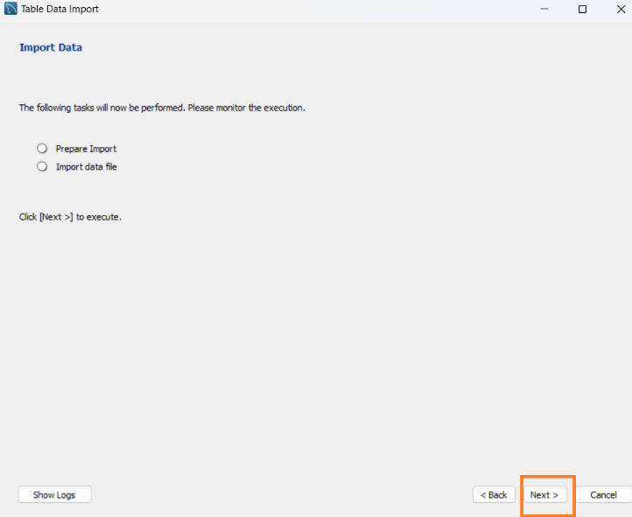

Once the Data import is complete click **Next**

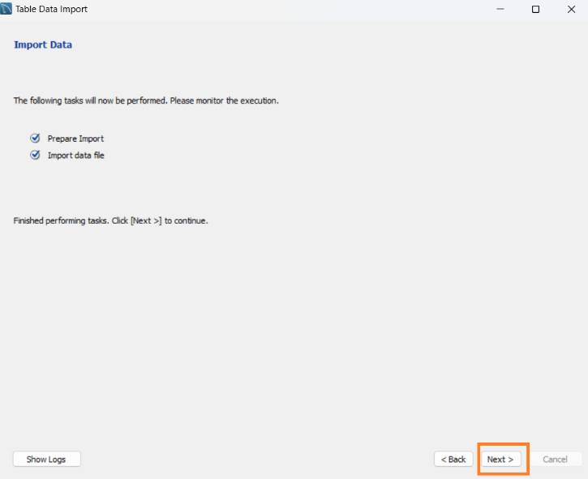

Click Finish

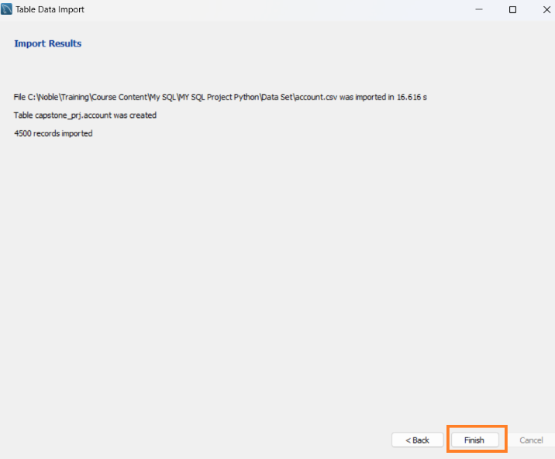

**Count the number of records in each table**

select Count(*) from account;

select Count(*) from card;

select Count(*) from client;

select Count(*) from disp;

select Count(*) from district;

select Count(*) from loan;

select Count(*) from orders;

select Count(*) from transaction_data;

**Once the .csv files are loaded create additional aggerate tables as specified.**

**#Transaction and Loans table**

CREATE TABLE loan_trans AS

select td.*,ln.loan_id,ln.date as loan_date,ln.amount as loan_amount,ln.duration,ln.payments,ln.status from loan ln

join transaction_data td on ln.account_id=td.account_id;

**#Account and Orders table**

create table acc_ord as

select o.*,acc.date as account_date,acc.district_id as account_district_id,acc.frequency from account

acc left join orders o on acc.account_id=o.account_id;

**#Card and Disposition table**

create table card_disp as

select card .*,disp.account_id,disp.client_id as disposition_client_id,disp.type as disposition_type from card card

join disp disp on card .disp_id=disp.disp_id;

**#Card and disposition combine with Client table based on client_id**

create table card_disp_clent as

select * from card_disp cd join client c on cd.disposition_client_id=c.client_id;

**#Card, Dispositon, client table with district Table based on district id (inner join)**

create table card_disp_client_dist as

select * from card_disp_clent cdc join district dist on cdc.district_id=dist.A1;

**#Account, order table with card, disposition, client, district table based on account id (left join)**

create table acc_ord_card_disp_client_dist as

select cdcd.*,ao.order_id,ao.bank_to,ao.account_to,ao.amount,ao.k_symbol,ao.account_date,ao.account_district_id,ao.frequency from acc_ord ao left join card_disp_client_dist cdcd on ao.account_id=cdcd.account_id;

**Use the following SQL from Python to access data**

**# Join account, order, card, disposition, client, district with loan, transaction table based on account_id (inner join)**

select * from acc_ord_card_disp_client_dist aocdcd join loan_trans lt on lt.account_id= aocdcd.account_id